**Superior View of the Skull Labeling Activity**

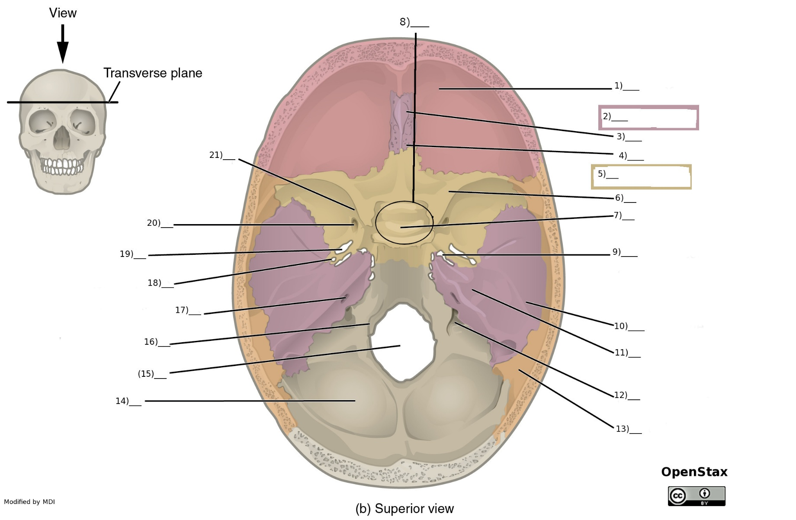

Word Bank

1. Frontal bone
2. Cribiform plate
3. Foramen ovale
4. Cristal galli
5. Temporal Bone
6. Foramen rotundum
7. Sphenoid bone
8. Hypoglossal canal
9. Hypophyseal fossa
10. Lesser wing
11. Parietal bone
12. Foramen lacerum & Exit of the Cartoid Canal
13. Occipital bone
14. Foramen magnum
15. Foramen spinosum
16. Jugular foramen
17. Superior orbital fissure
18. Ethmoid bone
19. Internal acoustic meatus
20. Petrous ridge
21. Sella turica

Answer Key

1. Frontal bone
2. Ethmoid bone
3. Cristal galli
4. Cribiform plate
5. Sphenoid bone
6. Lesser wing
7. Hypophyseal fossa
8. Sella turcica
9. Foramen Lacerum & Exit of the carotid canal
10. Temporal Bone
11. Petrous ridge
12. Jugular foramen
13. Parietal bone
14. Occipital bone
15. Foramen magnum
16. Hypoglossal canal
17. Internal acoustic meatus
18. Foramen spinosum
19. Foramen ovale
20. Foramen rotundum
21. Superior orbital fissure